CSE 595 Independent Study

Graph Theory

Week 1

California State University - San Bernardino

Richard Vargas

Supervisor – Dr Owen Murphy

Problem 1 (Introduction)



The following nodes represent boxes with certain color of wires in them and are connected if they have at least one color the same inside of them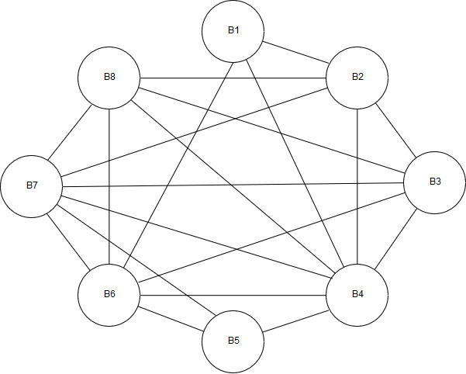.

Problem 3 (Degree of a Vertex)



By Theorem 1.4 in Chartrand [1],

$$\sum_{v∈V\left(G\right)}{\deg{v}}=2\left(m\right)∴2\left(m\right)=116$$

Where $m$ is the size of *G*.

Finding the remaining vertices that have not been given,

$$n-5-6-7=8$$

Where $n$ is the order of *G*.

Next find the remaining degrees shared among the 8 vertices,

$$116-5\left(4\right)-6\left(5\right)-7\left(6\right)=24$$

Dividing the 24 degrees among the 8 vertices,

$$\frac{24}{8}=3$$

$$∴\deg\left(v\right)=3$$

For the remaining vertices $∎$

Problem 5 (Degree of a Vertex)



**Proof**

Graph *G* has the following degrees,

$$i+\left(i+1\right)+\left(i+2\right)=3(i+1), i∈Z^{+}$$

**Odd Case**

Substituting $i$ for an odd integer,

$$3\left[\left(2n+1\right)+1\right], n∈Z^{+}$$

$$=3[2(n+1)]$$

Which is an even number for any given $n$ which follows Theorem 1.4 [1].

Therefore, there is the following number of vertices with odd degree

$$\left(2n+1\right)+\left[\left(2n+1\right)+2\right]=2(i+1)$$

Dividing the amount by the total number of vertices

$$\frac{2\left(i+1\right)}{3(i+1)}=\frac{2}{3}$$

**Even Case**

Substituting $i$ for an even integer,

$$3\left[\left(2n\right)+1\right], n∈Z^{+}$$

This is not possible by Corollary 1.5 [1], which states

*Every graph has an even number of odd vertices*

Therefore, there is two-thirds of the vertices of *G* that have odd degree in this case. $∎$

Problem 7 (Isomorphic Graphs)



1. $ϕ:V\left(G_{1}\right)→V(G_{2})$ is defined by

$$ϕ\left(A_{1}\right)=C_{2}, ϕ\left(B_{1}\right)=G_{2}, ϕ\left(C_{1}\right)=B_{2}$$

$$ϕ\left(D_{1}\right)=D_{2}, ϕ\left(E_{1}\right)=F_{2}, ϕ\left(F_{1}\right)=A_{2}, ϕ\left(A_{1}\right)=E_{2}$$

The function is bijective, and all mutually adjacent vertices in $G_{1}$ are also mutually adjacent in $G_{2}$. Therefore, $G_{1}≅G_{2}.∎$

1. These graphs cannot be isomorphic as they are not of the same order. Therefore, there cannot exist a bijective function such that $ϕ:V\left(H_{1}\right)→V\left(H_{2}\right)$ meaning $H_{1}≇H_{2}.∎$

Problem 11 (Regular Graphs)



By definition, a regular graph has the following property

$$r=δ\left(G\right)=Δ\left(G\right)$$

Where $δ\left(G\right)$ refers to the smallest degree of a vertex in $G$, and $Δ\left(G\right)$ refers to the largest degree of a vertex in $G$.

Therefore, a nonregular graph must have the following property,

$$δ\left(G\right)≤r≤Δ\left(G\right)$$

Thus $Δ\left(G\right)>δ\left(G\right)$, however based on Corollary 1.5 [1] mentioned in problem 5, the difference must be $≥2. █$

Problem 13 (Regular Graphs)



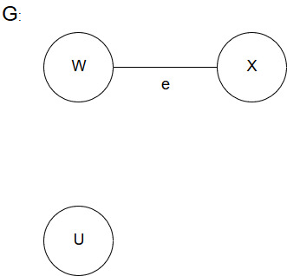Graph $G$ is nonregular,

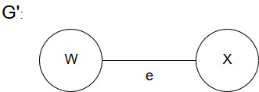Graph $G'$ deletes node $U$ and creates a 1-regular graph,

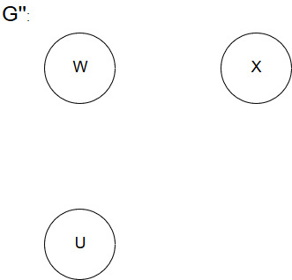Graph $G''$ deletes edge $e$ and creates a 0-regular graph,

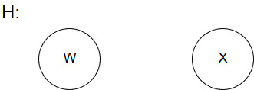Graph $H$ is deletes both edge $e$ and node $U$, and creates a 0-regular graph,

Works cited

“Introduction.” *Graphs & Digraphs*, by Gary Chartrand et al., CRC Press, 2016, pp. 1–13.